BHOPAL SAHAKARI DUGDH SANGH MARYADIT
HABIBGANJ, BHOPAL 462024
AN ISO 9001 : 2000 Certified Organization
E-mail: bsds@sancharnet.in,
Phone 0755-2478250-53 Fax : 0755-2450896

Ref No: 11 Dated: 08/03/2019

NOTICE INVITING TENDER (E-TENDER )

Online Tenders are invited for supply of PACKAGING MATERIALS at Bhopal Sahakari Dugdh Sangh from reputed manufacturer/distributor/dealer/suppliers. The tender documents containing the terms and conditions can be purchased online & downloaded through following website http://www.mptenders.gov.in from 8.3.2019 4.00 PM onwards. The tender will be opened in the office of the undersigned as mentioned in tender time schedule(key date). The detailed Tender Form can be seen (only for reference) at our H.O website: www.mpcdf.nic.in

Name of item | EMD  (Rs) | Tender Fee (Rs) | Bid submission due date & time | Technical Bid opening  Date & time
Packaging Materials | As per Schedule-II | 1000/- | 28.3.2019  2.30 pm | 29.3.2019  3.00 pm

CHIEF EXECUTIVE OFFICER

BHOPAL SAHAKARI DUGDH SANGH MARYADIT
HABIBGANJ, BHOPAL 462024
AN ISO 9001: 2000 Certified Organization
E-mail: bsds@sancharnet.in,
Phone 0755-2478250-53 Fax: 0755-2450896
DOCUMENT COST Rs. 1000/-

TENDER FOR PURCHASE OF PACKING MATERIALS

TENDER DOCUMENT

Schedule I : General Terms &Conditions.

Schedule II : Specification & Qnty & EMD
Schedule III : Form A & B
(To be downloaded filled manually & scanned copy uploaded online.)

Schedule IV : Price Schedule

Tender Cost : Rs.1000/-(Rupees One thousand only)

Place of opening of Tender : Meeting Hall of
The Bhopal Sahakari Dugdha
Sangh Maryadit, Bhopal.

Address for Communication : The CEO, Bhopal Sahakari
Dugdha Sangh Maryadit,
Bhopal 462024

CHIEF EXECUTIVE OFFICER

SCHEDULE - I
General Terms & Conditions for tender submission & supply

Bhopal Sahakari Dugdha Sangh Mydt, Bhopal (BSDSM), an ISO certified cooperative organization, invites sealed tenders from bonafide manufacturers and/ or their authorised dealers or other suppliers for supply of PACKING MATERIALS strictly in adherence to the detailed specifications given in the schedule II of the tender documents.
Bhopal Sahakari Dugdha Sangh Mydt., Bhopal reserves the right to accept or reject any or all tenders, which in their opinion justify such actions, without further explanation to the tenderers.
1.0 DECLARATION :
The submission of a tender by a tenderer implies that he/she has read the notice and conditions of the tender and the terms and conditions of contract and has made himself/herself aware of scope and specifications of the supplies to be made and the destination where the supplies have to be made and satisfied himself/herself regarding the quality and specifications of the articles.
2.0 TENDER SUBMISSION:
2.1 Tenders received by e-mail will not be considered. If hard copy not received till last date & time. However, amendments by e-mail to a tender sent will be considered, provided the same are received before the opening of the tender and confirmed by post.
2.2 The tenderer(s) should clearly state in their offer the address, telephone, fax, e-mail, PAN and GST Numbers. Any change in the address should immediately be communicated to the Chief Executive Officer, Bhopal Sahakari Dugdh Sangh Mydt, Bhopal and correspondence thereafter will be made at the changed address.
2.3 Negligence on the part of tenderer in filling the tender form offers him/her no right to withdraw the tender after it has been opened.
2.4 The acceptance of the tender and award of the purchase order will be the sole right of the Chief Executive Officer, Bhopal Sah. Dugdha Sangh Mydt. who does not bind himself to accept a tender in whole or in part or reject any or all the tenders received without assigning any reasons and no explanation can be demanded of the cause of rejection of the tender by any tenderer.
2.5 The Chief Executive Officer, BSDSM reserves the right to place order for whole requirement with any tenderer or split the orders among one or more tenderers or not to purchase at all any item even after rate approval.
2.6 Each tender should be accompanied with copy of PAN, income tax clearance certificate, sales tax number and sales tax clearance certificate.
2.7 The tenderers should submit the rates online only. The conditional tenders are liable to be rejected.
2.8 No person or firm is permitted to submit more than one tender under different names.
2.9 The tenderer shall not sublet the contract or assign to any other party or parties, the whole or any portion of the contract without prior written permission of Chief Executive Officer, BSDSM.
2.10 Manufacturers will be given preference. Copy of license is to be attached with tender for each item filled in, wholesalers dealing with the item will have to attach copy of authorization certificate of the manufacturer.
2.11 Tenderer shall fill all the details of the unit in the enclosed form- A,B in schedule-III. (To be uploaded –mandatory.)

Bid Validity
Bid shall be valid for a period of 90 days from the date of opening.

Documents composing the Bid

Technical bid:
1. Technical bid (Form A&B) filled( to be uploaded)
2. Online EMD transaction acknowledgement
3. Tender document each page sealed and signed as token of acceptance to each and every terms and conditions.
4. Technical documents/bid should reach physically in BSDS, Bhopal upto 3.00 pm 29.3.2019.

Commercial Bid
- Commercial Bid form filled

Bid price
Price indicated on the price schedule shall be inclusive of Service tax, pkg & frdg & freight.
GST (to be shown extra)

3.0 Earnest Money Deposit (As per Schedule-II)
EMD should be submitted online only and attach copy of proof for payment of EMD in technical bid.
3.2 Any tender which is not accompanied by Earnest Money deposit are liable to be rejected. Earnest money deposit of unsuccessful tenderers will be returned within 90 days from the date of opening of the tender. The earnest money deposit of the successful tenderers will be released on completion of supply/work as the case may be within the stipulated period.
3.3 No interest will be paid on the earnest money for the period during which (the EMD) lies in deposit with Bhopal Sahakari Dugdha Sangh.Maryadit.
- EMD may be forfeited :
- If successful Bidder/supplier fails/denies to perform work
- If any bidder/supplier withdraw its bid during the bid validity period

4.0 PRICES:
Prices offered by the tenderers should be firm and free from all escalations and shall be valid at least for a period of 12 months from the date of approval of rates. BSDS will have the right to extend the validity of the tender approval by 3 months. We would communicate our rate approval within 60 days of opening of tender. If any tenderer wish to offer the rate subject to PRICE ESCALATION CLAUSE of raw materials, they may do so by clearly indicating in the tender rate form –B.
In case of a tenderer opting for offering prices subject to PRICE ESCALATION CLAUSE of raw materials (i)then the tenderer shall have to submit the current price of the raw materials as on the date of tender along with sufficient authentic proof from the manufacturer of the raw material.
(ii) the successful/approved firm will have to submit revised prices of raw materials with sufficient authentic proof from the manufacturer of the raw material whenever revision takes place.
(iii) accordingly the approved prices of the materials shall be revised upwardly or downwardly to the extent of the raw material component of the material.
- The tenderer should quote rate on FOR dairy plant, Bhopal basis, GST extra.
4.2 If need be, negotiations will be done for prices and as well as terms & conditions of material supply only with the party which offers the lowest rate.
5.0 MODE OF DESPATCH
5.1 The material to be supplied by successful firm shall be dispatched to the dairy under prior intimation. Depending upon the type of material, the supplier shall have to carry out proper packing/crating to avoid damage during transit.
5.3 Wharfage /Demurrage etc. on account of incorrect or delayed despatch of material/documents shall be the responsibility of supplier and shall be recovered from the bills.
- LIQUIDATED DAMAGES;

6.1 Delivery date are fixed for supply of material they shall be strictly adhered too. In case they are not followed, or in case of delay in execution or non-execution of the order, the Dugdha Sangh reserves the right either to cancel the order and make alternative purchases from other sources, at the risk and cost & expenses of the defaulting supplier. In case the supplies are not affected as per the schedules, the liquidated damages may be charged on the goods not so delivered as under:-

Sl.No. | Duration of delay | Liquidated Damages
1. | Upto 15 days | 1% cost of the unit.
2. | Between 16 to 30 days | 2% cost of the unit
3. | Beyond 30 days | Upto 5% cost of the unit.

  - If the tenderer fails to make supply as per purchase order without any valid reason, the order would be treated as cancelled and the firm may be blacklisted for future dealings and EMD also would be forfeited by the management.

7.0 INSURANCE:

Insurance is to be arranged by the tenderer.

8.0 INSPECTION:

8.1 All the supplies are subject to inspection at our plant before acceptance. If goods are rejected due to defective or wrong supply, the report of our authorized official in this respect shall be FINAL and no correspondence on the subject would be entertained. The rejected goods should be removed from our premises by the tenderer within 15 days after receipt of our inspection report failing which the same shall be returned to the supplier at his risk and expenses or disposed off in Auction and the proceeds, if any, less expenses would be credited to tenderer's account.

8.2 Sample of the articles should be sent/produced before the competent authority if asked for within 7 days or as mutually agreed.

9.0 PAYMENT
9.1 Our normal terms of payment is full payment after receipt, inspection and acceptance of materials in our stores within a period of about 30 days after receipt. Such payments shall be made through RTGS.
10. TERMINATION OF CONTRACT:
If any act of commission or omission of a unit under contract brings Bhopal Sah. Dugdha Sangh Mydt. to dispute, then Bhopal Sahakari Dugdha Sangh Mydt. shall be competent to debar/blacklist the unit from further business.

11.0 CONSEQUENCES OF BREACH OF AGREEMENT:
If any firm under the contract commits breach of any of the conditions, it shall be lawful for the Chief Executive Officer, Bhopal Sahakari Dugdha Sangh Mydt. to cancel the contract and to purchase material from any other alternate sources on the risk and cost of the defaulting unit.

12. DISPUTE ARBITRATION & FINAL AUTHORITY:

12.1 It should be clearly understood that in the event of a successful tenderer failing to accept and execute the supply order, then decision of the Chief Executive Officer, Bhopal Dugdha Sangh Mydt., in this respect will be final and binding on the successful tenderer.

12.2 For all matters of dispute, the decision of the Honourable Chairman, Bhopal Sah. Dugdha Sangh Mydt. Under Arbitration and Conciliation Act. 1996 shall be final and binding on all the concerned.

12.3 For all disputes, the venue for legal course shall be at Bhopal.

Chief Executive Officer
Bhopal Sahakari Dugdha Sangh Mydt. Bhopal

@@@@@@@@

BHOPAL SAHKARI DUGDHA SANGH MARYADIT
HABIBGANJ DAIRY PLANT ; BHOPAL
SCHEDULE - II

PACKAGING MATERIAL FOR MILK & MILK PRODUCTS

- Milk Pouch Crates :
Approx. qnty: 40,000 Nos. EMD required: Rs. 75,000/-

Suitable : To hold 20 nos ½ litre milk pouches & stackable
- Material : Food grade HDPE
- Size : 568± 3mm x 298 ± 3mm x 173± 3mm outer dimensions
498 ± 3mm x 228 ± 3mm x 164 ± 3 mm inner dimensions
- Weight : 1200 ± 50 gms
- Colour : Blue
- Printing : BHOPAL SAHAKARI DUGDHA SANGH MARYADIT.
SANCHI
(to be screen printed on one side in Hindi and another side in English)
- Drop Test - : Shall pass the drop test

- Printed Plastic Cups & Glasses
- Shrikhand 100 gms. cup
Approx. Qnty. 20 lacs EMD Required Rs.20,000/-
- Material : PP white colour
- Total height : 50 ± 1mm
- Mouth dia O.D. : 80 ± 1mm
- Neck (of cup) O.D : 71 ± 1mm
- Coller width : 5mm (width of cup edge)
- Bottom dia O.D : 50 mm ± 1 mm
- Weight of cup : 5.0 ± 0.2 g
- Full capacity : 118 ml
- Actual shape of cup : As per provided sample by sangh
- Thickness : Should be uniform
- Printing matter, design & Bar code : Provided by Sangh to print on cups.
If Bar Code not scanned consignment will be rejected.
- General requirement : Strictly as per Annexure ‘A’
B. Chhena Rabari 100 gm. cup
Approx. Qnty. 3 lacs EMD Required Rs. 5,000/-
- Material : PP white colour
- Total height : 50 ± 1mm
- Mouth dia O.D. : 80 mm ± 1mm
- Neck (of cup) O.D : 71± 1 mm
- Coller width : 5mm (width of cup edge)
- Bottom dia O.D : 50 mm
- Weight of cup : 5.0 ± 0.2 g
- Full capacity : 118 ml
- Actual shape of cup : As per provided sample by sangh
- Thickness : Should be uniform
- Printing matter, design & Bar code : Provided by Sangh to print on cups.
If Bar Code not scanned consignment will be rejected.
- General requirement : Strictly as per Annexure ‘A’
C. Sweet curd 100 gm. cup
Approx. Qnty. 15 lacs EMD Required Rs.20,000/-
- Material : PP white colour
- Total height : 50 ± 1mm
- Mouth dia O.D. : 80 ± 1mm
- Neck (of cup) O.D : 71± 1 mm
- Coller width : 5mm (width of cup edge)
- Bottom dia O.D : 50 mm
- Weight of cup : 5.0 ± 0.2 g
- Full capacity : 118 ml
- Actual shape of cup : As per provided sample by sangh
- Thickness : Should be uniform
- Printing matter, design & Bar code : Provided by Sangh to print on cups.
If Bar Code not scanned consignment will be rejected.
- General requirement : Strictly as per Annexure ‘A’

D. Lassi- 200 ml. glass
Approx. Qnty. 15 lacs EMD Required Rs.25,000/-
- Material : PP white colour
- Total height : 90 ± 1mm
- Dimension : Mouth - O.D - 80 mm ± 1mm
I.D - 72 mm ± 1mm
- Bottom Dia : O.D - 50 mm
- Weight of cup : 6.5 ± 0.5 g
- Full capacity : 245 ml
- Printing matter, design & Bar code : Provided by Sangh to print on cups.
If Bar Code not scanned consignment will be rejected.
- General requirement : Strictly as per Annexure ‘A’

- Plain curd 200 gm. cup with suitable lid
Approx. Qnty. 10 lacs EMD Required Rs.20,000/-
- Breathing space : 50 ml
- Material : PP white colour
- Total height : 46 ± 1 mm
- Mouth dia O.D. : 115 ± 2 mm
I.D : 108 ± 2 mm
- Weight of cup : 12.5 ± 2 g
- Weight of lid : 6.5 ± 1 g
- Lid : Lid should be properly fixed on cups
- Printing matter, design & Bar code : Provided by Sangh to print on cups.
If Bar Code not scanned consignment will be rejected.
- General requirement : Strictly as per Annexure ‘A’

- Plain curd 500 gm. cups with suitable lid
Approx. Qnty 4,00,000. EMD Required Rs.15,000/-
- Breathing space : 100 ml (Total volume 600ml)
- Material : PP white colour
- Total height : 80 ± 1 mm
- Mouth dia O.D. : 120 ± 2 mm
I.D : 111 ± 2 mm
- Weight of cup : 18.4 ± 0.5 g
- Weight of lid : 6.5 ± 1 g
- Lid : Lid should be properly fixed on cups
- Printing matter, design & Bar code : Provided by Sangh to print on cups.
If Bar Code not scanned consignment will be rejected.
- General requirement : Strictly as per Annexure ‘A’

- Shrikhand 500 gms. cup with suitable lid
Approx. Qnty. 50,000 Nos. EMD Required Rs. 5,000/-
- Material : PP white colour
- Total height : 64 ± 1mm
- Mouth dia O.D. : 122 ± 1mm
- Weight of cup : 17.5 ± 2 g
- Weight of lid : 8 ± 1 g
- Lid : Lid should be properly fixed on cups
- Printing matter, design & Bar code : Provided by Sangh to print on cups.
If Bar Code not scanned consignment will be rejected.
- General requirement : Strictly as per Annexure ‘A’

- Chhena Rabari 500 g cup with suitable lid
Approx. Qnty. 50,000 Nos. EMD Required Rs. 5,000/-
- Material : PP white colour
- Total height : 80 ± 1mm
- Mouth dia O.D. : 120 ± 2mm ID 111 +- 2mm
- Weight of cup : 18.4 ± 0.5 g
- Weight of lid : 6.5 ± 1 g
- Lid : Lid should be properly fixed on cups
- Printing matter, design & Bar code : Provided by Sangh to print on cups.
If Bar Code not scanned consignment will be rejected.
- General requirement : Strictly as per Annexure ‘A’

- Butter box 200 g with suitable lid
Approx. Qnty. 20,000 Nos. EMD Required Rs. 1,000/-
- Material : PP B 400MN/B550MN of RIL or equivalent PP grade
- Volume : 235 ml
- Color of box/lid : White Opaque
- Weight of box : 8.5 ± 0.5 g
- Weight of lid : 4.5 ± 0.5 g

- Mawa Cup 500 g cup with suitable lid
Approx. Qnty. 50,000 Nos. EMD Required Rs. 5,000/-
- Material : PP white colour
- Total height : 64 ± 1mm
- Mouth dia O.D. 122 ± 1mm
- Weight of cup : 17.5 ± 2 g
- Weight of lid : 8 ± 1 g
- Lid : Lid should be properly fixed on cups
- Printing matter, design & Bar code : Provided by Sangh to print on cups.
If Bar Code not scanned consignment will be rejected.
- General requirement : Strictly as per Annexure ‘A’

General requirements : Annexure ‘A’
i. Thickness of the cup wall should be uniform without cracks
ii. The cups should be free from dirt and dust particles, free from
odour, packing should be under hygienic condition.
iii. Rates be quoted for Multi colour printing as per Sangh Art work.
iv. Please quote rates for lids and cups separately where ever required
However rates be also mentioned for cups & lids.
v Bottom of the cup should be flat.
vi Material should be virgin food grade plastic
(Supplier have to produce certificate for food Grade material & Printing ink approved for use for milk products packets)
vii Printing matter with vegetarian green symbol and shape can be seen from this office.
3. Ghee refill carton for 1 litre/500ml/200ml sizes : (Ceka Pack/Ordinary)
A. Ceka Pack
(A) 1000 ml Approx. qnty. 5,00,000 nos EMD Rs. 30,000/-
(B) 500ml Approx. qnty. 4,00,000 nos EMD Rs. 20,000/-
(C) 200 ml Approx. qnty. 1,00,000 nos EMD Rs. 5,000/-
Specification of Ceka Carton with plain liner
- Type of Carton : Ceka Carton(12 Mic Met Pet/75 Mic Poly (LD/LLD/HD 25% dowlex)
- Paper Specification : Khanna Optic/ITC or equivalent Grey back 400 Gsm
- Printing : Multi colour printing
- Coating : Film Lamination 10 mic
- Die Cutting : Cutting as per layout
- Packing : Packed in Corrugated Carton Boxes 5 PLY
- Art work & Bar code : As per Sangh art work & colour.
If Bar Code not scanned consignment will be rejected.

- Dimensions: L W H
- 1 Litre 102 mm 70 mm 168 mm
- 500 ml 86 mm 61mm 115 mm
- 200 ml 72 mm 42 mm 85 mm
Other requirements for all the above three sizes :-
i) The duplex boxes of Ghee are for AGMARK quality ghee. Hence only Agmark approved printing press should apply.
ii) If GSM is less then 400± 5% GSM then the consignment will be rejected.
iii) Printing : Multi colour print as per our approved sample with design of artwork & Bar code
iv) Paper should be neat and clean, free from fungus, insects etc. Only of food grade quality, gums with anti-fungal properties shall be used.
B) Ghee refill carton (Ordinary)
Size :200 ml Approx. qnty. 1,00,000 nos EMD Rs. 5,000/-
Dimensions : 110 x 90 x 35 mm I.D.
Type of paper Board : Cyber excel Board from I.T.C mill with aquavarnish coating white food grade material with certificate.
G.S.M : 300 ± 5% Bursting strength: 7 - 8 kg /cm2
Lamination : Complete out side of cartons excluding flaps
Printing & Bar code : As per the provided design of Sangh.
4. Peda duplex boxes 250g/500g/ 1 kg
(A) 250 g Approx. qnty. 2 lacs EMD Rs.10,000/-
(B) 500g Approx. qnty. 1 lac EMD Rs.7,000/-
(C) 1 Kg Approx. qnty. 15,000 nos EMD Rs.3,000/-
(D) 40 g (2 peda) Approx. qnty. 10,000 nos EMD Rs.500/-
Dimensions & General Conditions
L W H
- 250 g : Top of Box - I.D (mm) 110 x 78 x 45
Bottom of Box- I.D (mm) 108 x 76 x 45
L W H
- 500 g : Top of Box - I.D (mm) 170 x 115 x 40
Bottom of Box- I.D (mm) 168 x 113 x 40
L W H
- 1 kg. : Top of Box - I.D (mm) 260 x 150 x 40
Bottom of Box- I.D (mm) 258 x 148 x 40
- 40 gm ID (mm) 70 x 45 x 25

Material : Duplex box sheet made of virgin quality & Food grade with Food grade material certificate.
Type of box: Universal type with single joint
GSM – 370+/-5% (for 250 gm, 500 gm & 1 kg box)
300+/-5% (for 40 gm pack)
Lamination : Lamination proper and food grade on complete inner and outer side of box.
Printing: As per approved design & multicolour on all side of outer surface of box with bar code.
Packing & delivery - Pack should be hygienic & delivery in dairy in most hygienic conditions.

5. Milk Cake duplex boxes 250g/500g/1 kg

(A) 250 g Approx. qnty. 1 lac EMD Rs.5,000/-
(B) 500g Approx. qnty. 50,000 nos EMD Rs.5,000/-
(C) 1 Kg Approx. qnty. 10,000 nos EMD Rs.5,000/-
(D) 40 g (2 milk cake) Approx. qnty. 10,000 nos EMD Rs.500/-
(E) 30 g (2 nariyal barfi) Approx. qnty. 10,000 nos EMD Rs.500/-
Dimensions & General Conditions
L W H
- 250 g : Top of Box - I.D (mm) 110 x 78 x 45
Bottom of Box- I.D (mm) 108 x 76 x 45
L W H
- 500 g : Top of Box - I.D (mm) 170 x 115 x 40
Bottom of Box- I.D (mm) 168 x 113 x 40
- 1 Kg : Top of Box - I.D (mm) 260 x 150 x 40
Bottom of Box- I.D (mm) 258 x 148 x 40
- 40 gm/30 gm ID (mm) 70 x 45 x 25

6. Nariyal Burfi duplex boxes 250g/500g

(A) 250 g Approx. qnty. 50,000 nos EMD Rs.2,000/-
(B) 500g Approx. qnty. 25,000 nos EMD Rs 2,000/-
Dimensions & General Conditions
L W H
- 250 g : Top of Box - I.D (mm) 140 x 112 x 40
Bottom of Box- I.D (mm) 138 x 110 x 40
L W H
- 500 g : Top of Box - I.D (mm) 205 x 40 x 40
Bottom of Box- I.D (mm) 203 x 38 x 40
GENERAL CONDITIONS:-
Material : Duplex box sheet made of virgin quality material.
G.S.M : 370 ± 5%, 300+/-5% (for 40 gm pack)
Lamination :- Lamination proper and food - grade on complete inner side and out side of box, Type of Box :- Two piece box as per sample.
Printing:- As per approved design and multicolour on top piece of the box with Bar Code.
All the boxes shall be clean, dry and free from fungus, insect infection, dust etc.
Extra care should be taken for maintenance of cleanliness and delivery of boxes in the dairy in most hygienic conditions.
7 Corrugated Boxes (Printed in single colour) with Vegetarian Green Colour symbol.
Sr  No | Particulars | Size mm  I.D | GSM  per ply | Ply | B.S. min Kg/sq.cm | Aprox. Qty Reqr | EMD
A | For 20 kg  white butter | 410x355x175  Staples 8 | 150 ± 5% | 5 | 12kg/cm2 | 50,000 Nos | 20,000/-
B | Ceka Pack  1 lit.x16 Nos. | 425 x 285 x 175  Staples 6-8 | 150 ± 5% | 3 | 6.0 | 40,000 Nos | 10,000/-
C | Ceka Pack  ½ lit x 32 pkts. | 370 x 270 x 245  Staples 6-8 | 150 ± 5% | 3 | 6.0 | 20,000 Nos | 5,000/-
D | Ceka Pack  200ml x 80 pkts. | 430 x 300 x 175  Staples 6-8 | 150 ± 5% | 3 | 6.0 | 5,000 Nos | 2,000/-
E | For Sanchi ghee of  200ml x 80 pkts. | 460 x 380 x 195  Staples 6-8 | 150 ± 5% | 3 | 6.0 | 10,000 Nos | 3,000/-
F | For Shrikhand  100gx20cup with centre plate | 405 x 165 x 105 | 150± 5% | 3 | 6.0 | 1,00,000 nos | 10,000/-
 |  | 395x155 | 150± 5% | 3 | 6.0
G | For Sweet curd  100gx20cups with centre plate | 405 x 165 x 105  395x155 | 150± 5%  150± 5% | 3  3 | 6.0  6.0 | 80,000  Nos | 8,000/-
H | For Cheena Rabari 100 g x 20 cups with centre plate
 |  | 405 x 165 x 105  395x155 | 150± 5%  150± 5% | 3  3 | 6.0  6.0 | 20,000nos | 5,000/-
I | For Lassi 200mlx20glass  With centre plate | 400 x 165 x 200  395x155 | 150± 5%  150± 5% | 3  3 | 6.0  6.0 | 80,000 Nos | 10,000/-
Other requirements for corrugated boxes

i Purchase order will be given only after approval of sample provided by supplier.
ii. Construction - Universal type boxes shall be constructed from single piece double
walled 5 ply or 3 ply heavy duty fibre board as per requirements, conforming to ISI 2771 Part 1 `1977. The fibre board must be derived from virgin kraft paper conforming to ISI-1397-1976 grade II. Only variation of ± 5% from the specified grammage for all plies for all types of boxes is permissible.
All five or three plies shall be unbituminized and each ply shall be of 150 gsm as stated above. The second and fourth ply shall be corrugated and embodied into the outer ply in a manner such that they can not be separated by pulling apart without damaging the paper and tearing it. All plies should be constructed from 150 gsm virgin kraft only.
iii Corrugation -The height of corrugation should be between 2.1 and 2.9 mm and there should be 150 to 155 corrugations per running metre length.
iv Gum - Permissible under law for sticking the 5/3 piece to form the corrugated box to be used for packing.
v Creasing, Scoring, Folding - The boxes should be creased and scored such that folding is appropriate and symmetrical.
vi Printing - All boxes to be printed as per prescribed design and single colour (sample will be available for reference.)
vii Joints - All boxes should have lap type of joints with minimum width of 30 mm. All stitches should be on the central axis of the lap at an angle of 45 degrees and total six staples should be used including double staples on upper and lower ends of the joints of boxes. Only GI wire of 12 to 25 SWG should be used for stitching.
viii. Packing - Boxes should be packed in bundles containing 20 units of each type of box and should be marked with supplier’s name and/or initials/trade mark, batch No. lot No. and dimensions.
ix Hygiene - All boxes shall be clean, dry and free from fungus, insect infestation, dust etc. As the boxes will be used to pack food products, extra care should be taken for maintenance of cleanliness and delivery of the boxes in the dairy in most hygienic condition.

8. Printed pouches for paneer E.M.D Rs. 5,000/-
Material :3 Layered structure of polyster, metalised polyster and LDPE film
(i) Suitable for : Vacuum packing of paneer
(ii) Size Qty. req. Width x height Thickness
200 g : 50000 nos (200 x 150) ± 5 mm 70 ± 5 micron
500 g : 20,000 nos (235 x 175 ) ± 5 mm 70 ± 5 micron
1 Kg : 10,000 nos (255 x 215) ± 5 mm 70 ± 5 micron
- Printing as per BSDSM design and multi colour art work & BAR Code

- Material must be of food grade quality.

9. Alu. Foils for cups
Size Thickness Req. nos E.M.D.
81 mm (for PP Material) 30 micron 40,00,000 Nos Rs. 10,000/-
Printing in one/two colour as per B.S.D.S. Art work.
Poly coated for PP cups. Food Grade with Certificate
10. Alu. Foils(200 g) for cooking butter packing
Approx. Qnty. 20,000 Nos. EMD Required Rs. 1,000/-
Dimension – Length 108 mm, Width 82 mm
Micron – 40 u suitable to use on P.P. container
Alluminium foil printed with Red colour SANCHI as per annexure-1
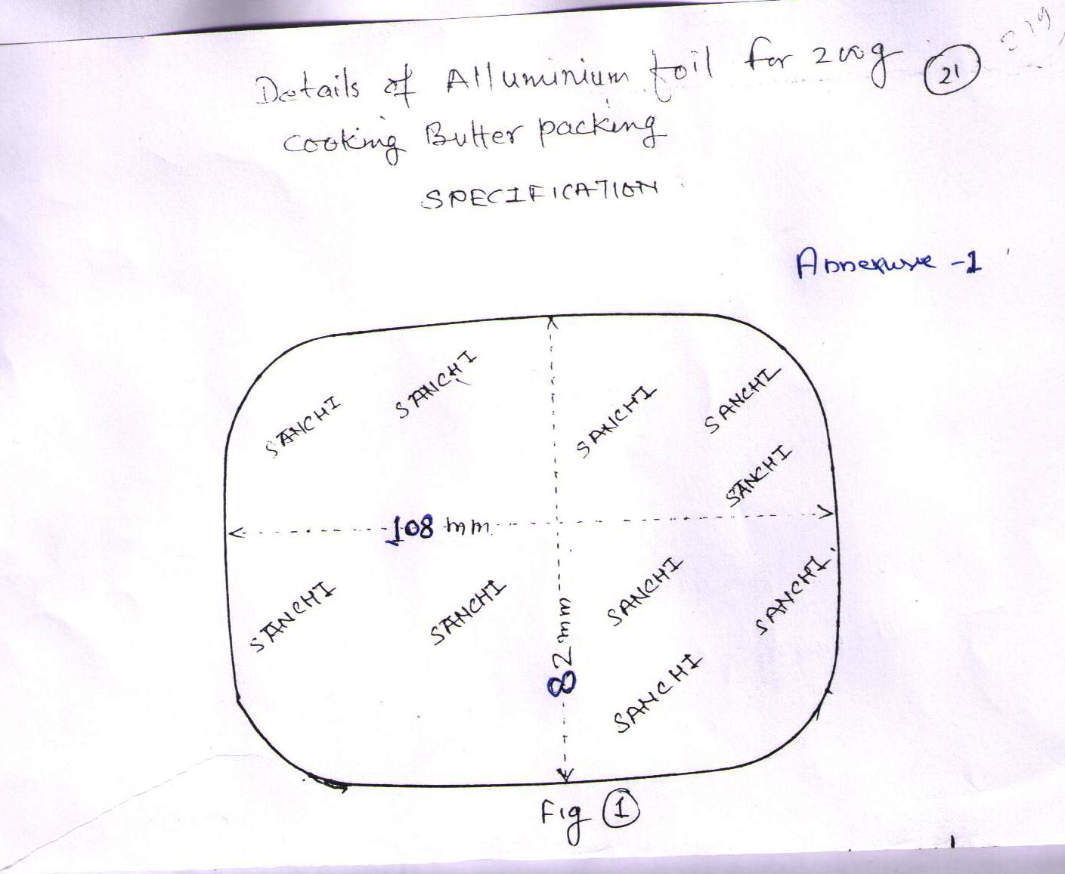
11. B O P P Tapes Req. nos E.M.D.
Size: 48 mm x 130 metres (two colour printed) 5000 Rs.3000/-
18 mm x 65 metres (two colour printed) 2000 Rs.1000/-
12 mm x 50 metres (unprinted) 2000 Rs.1000/-
Other requirements : Thickness of film : 25micron
Thickness of adhesive :23 micron
Tensile strength minimum :3.8 kg cm2
Elongation maximum :60%
All tapes with good quality / strength, one side adhesiveness.
12. Tanker seal
Approx Qty. 30,000 Nos EMD Rs. 6,000/-
Length for (A)* | 93 ±2 mm
Length for (B)* | 36 ±1 mm
Diameter for C)* | 19.5 ±1 mm
Diameter ID for (D)* | 08 ±1 mm
Diameter for (E)* | 10 ±1 mm
Diameter for (F)* | 07 ±1 mm
Length for (G)* | 19 ±1 mm
Metal | High grade steel
Plastic | ABS
Type | Anti-spin
Marking | Unique marking of seal no with manufacturer name.logo of parts
Shear Test | Load to failure (3.336 KNª**) High security (As per ISO 17712:2013)
Bending moment to failure | Minimum 50 Nmª(As per ISO 17712:2013)
Tensile Test | Load to failure (10.0 KNª**) (As per ISO 17712:2013)
Impact Test | Load to failure (40.68 J) (As per ISO 17712:2013)
Testing | Supplier will sent with each consignment testing certificate from NABL Certified Lab.
For A,B,C,D,E,F,G* | Enclosed artwork with dimensions  (Annexure -2)

Bottle seal “Round” type ISO for container
(with laser logo & sl.nos in laser)
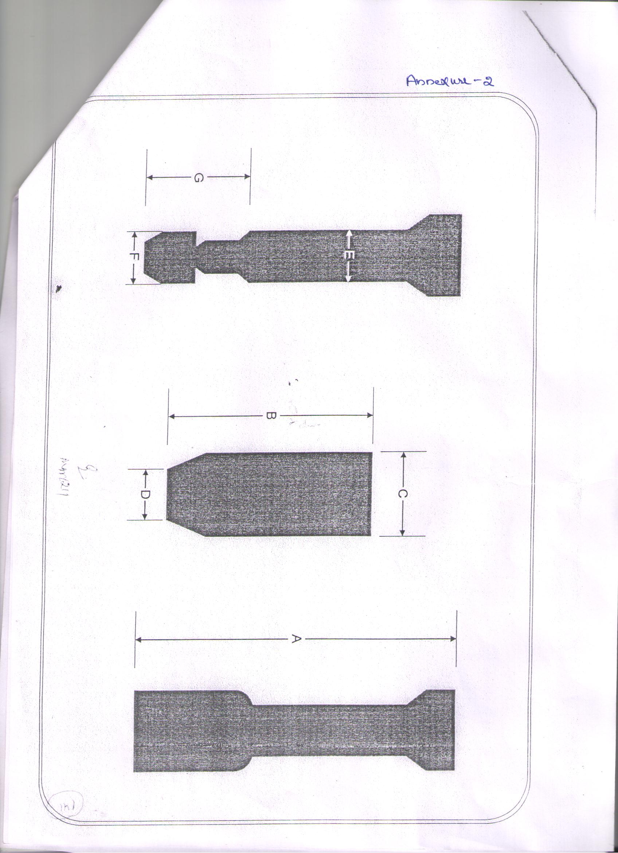

13. `Fevicol
Pidilite CPW Food Grade
Approx Qty. 1,000 kg EMD Rs. 5,000/-

*************

BHOPAL SAHAKARI DUGDHA SANGH MARYADIT, HABIBGANJ, BHOPAL 462024
SCHEDULE – III
Form – A
(To be uploaded - mandatory)
To,
Chief Executive Officer
BSDSM, Bhopal

Dear Sir,
Please find enclosed herewith scan copy of Online EMD transaction acknowledgement vide no………………dtd…………………Rs………………….towards EMD deposit.

Seal & Signature of the of the tenderer

BHOPAL SAHAKARI DUGDHA SANGH MARYADIT,
HABIBGANJ, BHOPAL 462024
SCHEDULE – III
Form – B
(To be uploaded -mandatory)
Chief Executive Officer Date :
BSDSM, Bhopal

Dear Sir,
I/We hereby furnish below some particulars about our company/unit which will form a part of our offer submission:
1. Name of the Co./Unit : __________________________________
2. Address of the Co./Unit : __________________________________
__________________________________
3. Telephone Nos.(with STD Code):__________________________________
FAX No. : __________________________________
Email ID : __________________________________
4. Name of the CEO/Proprietor/ :__________________________________
Partner
5. Name and designation of other :__________________________________
Authorized signatory of the Co./Unit
6. Particulars of Regn. Certificate :__________________________________
Issued by the competent authority
(Regn No. & Date)
7. We are manufacturer/distributor/dealer/supplier of …………….Co.(with proof)
8. GST NO ………………… dtd……………..
9. PAN Number(Permanent Account Number- Income Tax) :
10. Have your Co./Unit or its sister concern ever been black listed/ debarred by BSDSM or its sister Milk Unions or GOI /GOMP & its undertaking ? YES / NO
11. Price Escalation : YES/NO

Seal & Signature of the Authorized Signatory of the Co./Unit

BHOPAL SAHAKARI DUGDHA SANGH MARYADIT HABIBGANJ,
BHOPAL 462024

SCHEDULE – IV

Form – C

(PRICE BID) ONLINE ONLY

NIT Ref. No.
NAME OF TENDERER:

S.  No. | DESCRIPTION | Rate/unit F.O.R Dairy GST Extra.

(Seal & Signature of the tenderer)

